**User Documentation**

**Introduction:**

**User:**

Users can explore and analyze project and employee data through the OnShape Insights dashboard. By selecting specific projects or employees, users can view detailed statistics and visualizations related to actions, project involvement, and performance metrics. The dashboard offers various sections, including Main, Projects, Employees, Notifications, Upload JSON, ChatBot, and Collaborations each providing relevant information and functionality. Users can also filter data by year and view graphical representations of key metrics, enabling them to make informed decisions and track progress effectively. Additionally, users can engage in a conversation with a chatbot to ask questions about cloud computing, receiving immediate and relevant answers.

**Header on all the pages:**

* Click on Mainbutton, and then you will go to the Home page.
* Click on the Project button, and then you will go to the Project page.
* Click on the Employees button, and then you will go to the Employees page.
* Click on the Notifications button, and then you will go to the Notifications page.
* Click on the Upload json button, and then you will go to the Upload json page.
* Click on the ChatBot button, and then you will go to the ChatBot page.
* Click on the Collaborations button, and then you will go to the Collaborations page.

**Home page:**

* Summary Section:
  + Projects: The total number of projects.
  + Employees: The total number of employees.
  + Actions: The total number of actions performed.
* Employee Projects Table:
  + Displays a list of employees along with the number of projects they are involved in and their respective actions.
* Graphs:
  + Total Actions (Line Chart): This graph displays the monthly distribution of total actions for a selected year, which can be compared with the previous year. A dropdown menu allows selection of the year for this specific graph.
  + Top 5 Projects by Actions (Bar Chart): Details the top five projects by the number of actions, with a separate dropdown menu to select the year for this data.

**project page:**

The 'Projects' page allows users to select and view details related to specific projects. The page includes a dropdown menu to choose a project. After selecting a project, the page displays key information such as the number of employees involved, the total number of actions, and the overall modeling time. Additional statistics and graphs show data like "Actions Number per Tab," "Modeling Time per Date," "Percentage of Actions per User," and "Operations Count per Date." This section helps users track and analyze the actions performed within the project, providing a comprehensive overview of the project's activity, progress, and last edited date.

After selecting a project

**Employees page:**

The 'Employees' page provides an interface for users to view detailed statistics related to individual employees. The page includes dropdown menus to filter data by year, month, and user. After selecting the desired filters and clicking on the 'Filter' button, the page displays detailed information for the selected employee. This includes the total number of actions (created, edited, and deleted) distributed across different documents, a bar chart showing the actions distribution by day, and summary statistics such as the total number of projects, modeling time, elements created, elements added/inserted, and elements deleted. Additionally, a heatmap is provided, illustrating the number of actions performed by the employee, categorized by hour of the day and day of the week. This comprehensive data allows for an in-depth analysis of employee activity, productivity, and contributions over the selected period. Last graph shows graphs that have three type of actions and how it change each month which shows progress of the employee.A group of text boxes

After clicking on the Filter

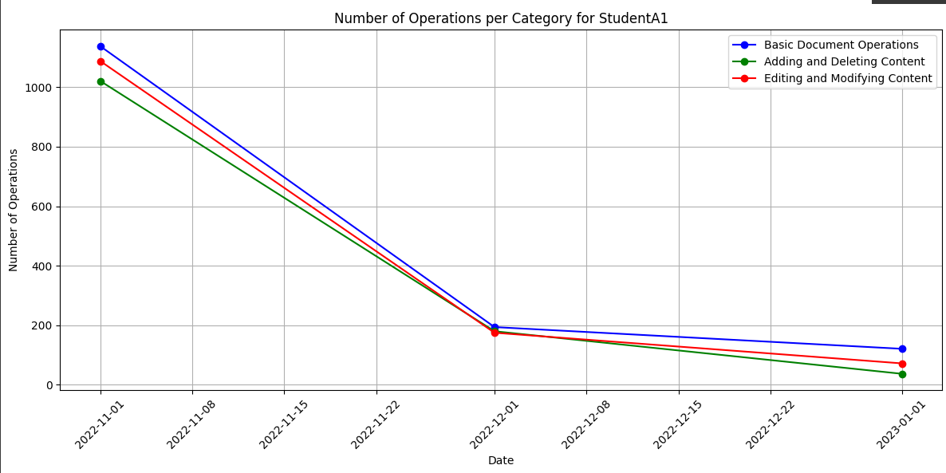

**chatBot page**

The 'ChatBot' page provides an interactive assistant for users to inquire about various aspects of the project management system. Users can type questions directly into the chatbot or select predefined suggestions from the dropdown menu. The ChatBot responds with relevant information, such as project details, document access statistics, and other management-related queries. For example, users can ask about the most frequently accessed document, and the ChatBot will provide an immediate response with the document's name and the number of accesses. This feature enhances user experience by offering quick and accessible information directly within the dashboard.

**Notifications page**

The 'Notifications' page provides an overview of important alerts and messages related to projects and employees. The page is designed to inform users about various events and issues, such as:

* Ditched Project**: Notifications indicate when a project hasn't had any work done for more than two weeks, suggesting that users take a look at these inactive projects.
* Employee Support Needed**: Alerts notify users if an employee might need assistance due to a backlog of operations or other issues, prompting consideration of additional support.
* Project Difficulties**: Warnings are provided when a project may be encountering challenges, such as multiple undo/cancel/delete operations, indicating potential issues that need attention.

Each notification is clearly labeled with a title and detailed message, along with a timestamp indicating when the notification was generated. This page helps users stay informed about critical issues, ensuring timely responses to maintain productivity and project progress.

**Upload JSON page**

The 'Upload JSON' page provides a simple interface for users to upload JSON files. The page features a dropdown menu to select an existing JSON file, and an "Upload" button to upload new files. After selecting a file, users can click the "Set as Data" button to integrate the selected file's content into the dashboard. This functionality is used for updating or adding new data, such as project details, employee statistics, or other relevant information, which will be reflected in the various sections of the dashboard.

**Collaborations page**

The 'Collaborations' page allows users to select a specific document from a dropdown menu to view detailed contributions made by different employees. After selecting a document, the page displays a bar chart illustrating the contributions of each employee to various parts or assemblies within the document. The chart provides a clear visual representation of the number of contributions made by each employee across different sections, helping users analyze collaboration and individual involvement in the project. This feature is particularly useful for understanding how different team members have contributed to the project's development.

After selecting a project

